# Installation Guide for the Infrastructure

The GAMES service center which runs the global loop presented in [1] and [2] needs to have the structure described in Figure 1.1.

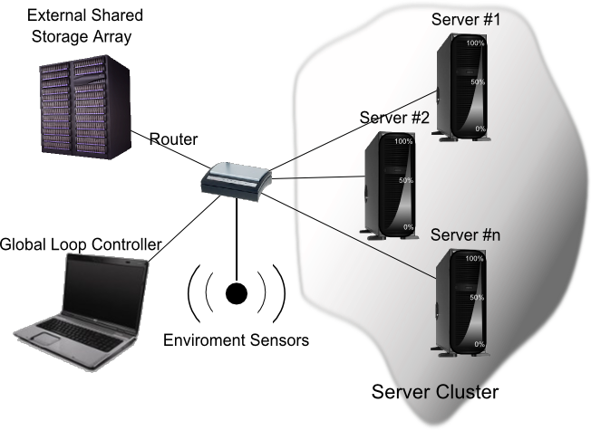

Figure 1.1:GAMES service center infrastructure

It has a number of servers in the role of nodes, on which Windows Server 2008 R2 needs to run. Each of the servers needs to support hardware assisted virtualization. If it doesn’t have the virtualization enabled, the hypervisor can’t be installed. Virtualization can be enabled from BIOS. If the BIOS version is old and the virtualization option doesn’t appear, it has to be updated. For this, the new BIOS version has to be downloaded, created a bootable flash and updated from it with BIOS or updated under windows if the motherboard enables you to do that.

After installing Windows Server 2008 R2 and enabling virtualization if it is not enabled, the Hyper-V and IIS roles need to be installed. This is done through the following steps:

* Click **Start**, and then click **Server Manager**.
* In the **Roles Summary** area of the Server Manager main window, click **Add Roles**.
* On the **Select Server Roles** page, click Hyper-V and Web Server IIS.
* On the **Create Virtual Networks** page, click one or more network adapters if you want to make their network connection available to virtual machines.
* On the **Confirm Installation Selections** page, click **Install**.
* The computer must be restarted to complete the installation. Click **Close** to finish the wizard, and then click **Yes** to restart the computer.
* After you restart the computer, log on with the same account you used to install the role. After the Resume Configuration Wizard completes the installation, click **Close** to finish the wizard.

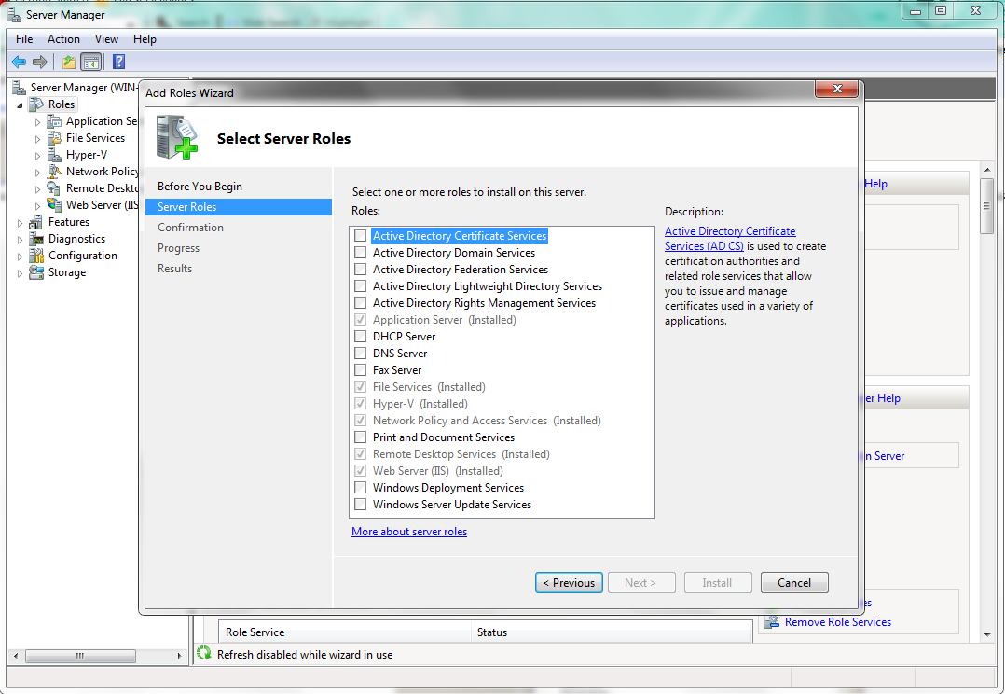

Figure .:Select Hyper-V and IIS roles

# Shared Storage Computer

A computer different from the nodes computers needs to exist in the current network, with a SharedStorage folder on it. This folder is used to store all the initial virtual machines and each server needs to have access to it in order to be able to run the virtual machines. The shared storage folder must be writeable from any server in this architecture. Here will be placed the virtual machines to be accessed from the existing servers. A virtual machine having the name VM_1 must exist because it is sued as template for the datacenter tasks. The machine should either have the IP address 192.168.2.110 or the IP should be changed from the program.

# Setup Windows 2008 R2 for wake on LAN

* Open ***Computer Management -> Device Manager***
* In the components list (**Error! Reference source not found.**) expand ***Network adapter* and select the network card in use.**
* Right click on it, ***Properties*** and select the ***Advanced*** tab from the properties window (Figure 2.2).
* Choose ***Wake Up Capabilities*** and set as value **ALL** or **Magic Packet**.

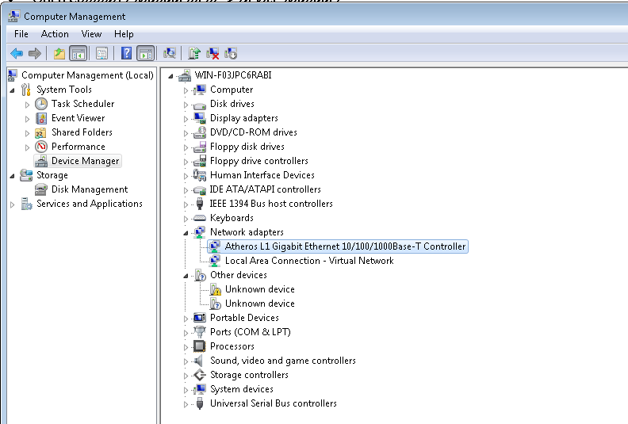

Figure . Device Manager

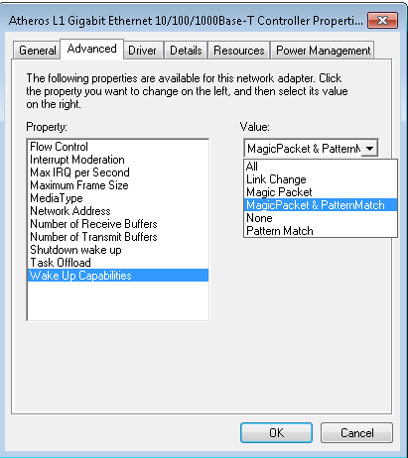

Figure .: Network Card Properties

# Enable Sleep on Windows 2008 R2 running Hyper-V

Hyper-V disables the sleep option when booting. Because Hyper-V automatically starts with windows, this must be disabled by modifying the registry. Also, to re-enable the Sleep or Hibernate options the operating system needs to be restarted. A script is register in RunOnce to run when the server wakes up which automatically sends the server to sleep. Another script is used to start hyper-V.

Copy **SendToSleep.exe, SendToSleep.vbs**  and **StartHVBoot.bat** on **C:\\** directly on the root. The two files are located in the **.\ASP.NET Web Services\**  folder.

# Setup IIS Server for each server for exposing the information gathering endpoint

* Open IIS
* Click on ***Sites***, right Click and ***Add site****.*  Create new Web Site, no matter what name. Choose the location of the C# web service files. Leave the other settings intact (Figure 4.1).

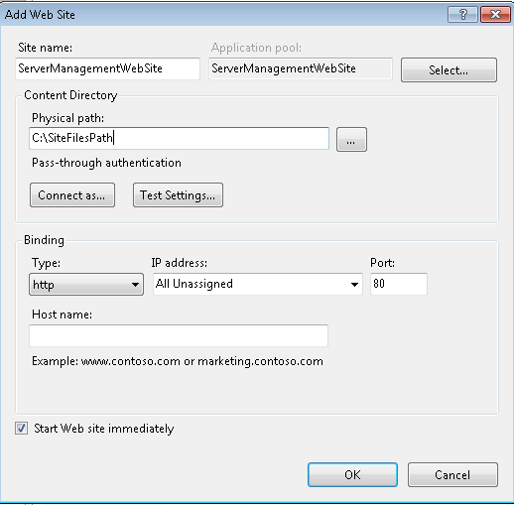

Figure .: Create Web Site

* Select the newly created site , select ***Add Application****.* Choose as name **ServerManagement**. Set the application pool to **ASP.NET 4.0**.Let the connection be as pass-trough authentification(Figure 4.2).

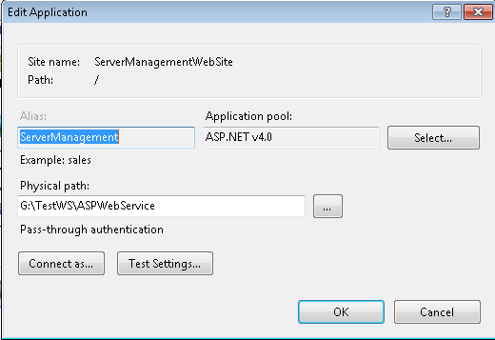

Figure .: Add application

* Right click on the newly created application and select ***Explore.*** Copy **all** the files from

**.\** **ASP.NET Web Services\ASPWebService-Site\**  in the folder opened with explore. The clientaccesspolicy and crosdomain files are needed for enabling http get and post methods t be invoked over internet.

* Still in the IIS Server Management window, select ***Application pool.***In the middle panel select all pools that are started (NOTE! If ASP.NET 4.0 is not started also select it.) Right click and choose ***Set Application Pool Defaults*** ().

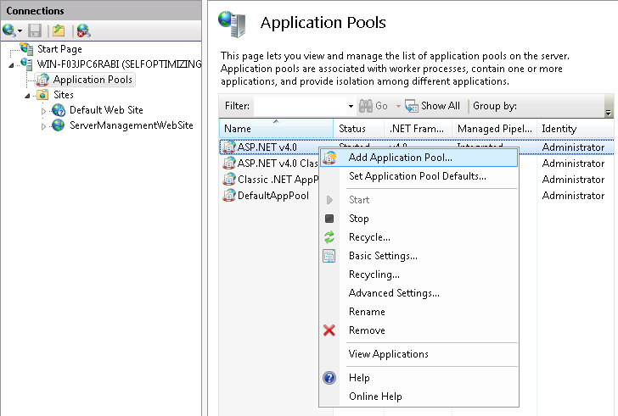

Figure .: Setup application pool access

* If **Start Automatically**  is not set to **True**(Figure 4.4) change it to ***True.***
* Select the ***Identity***  option, press the ***Browse(…)*** button , on the following dialog press ***Set*** and input the credentials of a user account which has administrator rights on this computer.

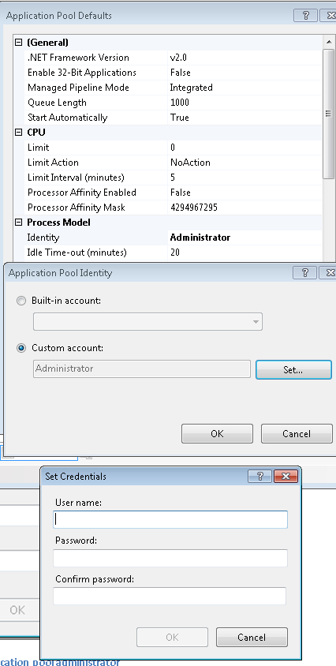

Figure .: Set application pool administrator

# Install X3D for the 3D context representation

Install X3D from the installation kit provided. **NOTE**: When running the application specify as virtual java machine parameters **-Djava.library.path="**path to x3d installation **"**.

**Example:** -Djava.library.path="C:\Program Files\Xj3D\bin"